**TOPBUILDER USER MANUAL**



**TOPBUILDER WEBSITE**

**USER MANUAL**

Worker's Personal Protective Equipment Detector and Incidents

_______________________________________________________________

**Contents**

Prerequisites 1

1. Python Installation 1

2. Tensorflow Installation 3

3. XAMPP Installation 4

4. Start Tensorflow Model 10

5. TOPBuilder Website 10

5.1. PPE image detection 12

5.2. PPE Video Detection 13

5.3. PPE Webcam Detection 14

5.4. Incident Image Detection 15

5.5. Incident Video Detection 16

5.6. Incident Webcam Detection 17

**List of Figures**

Figure 1.1 Python version on the website 1

Figure 1.2 Installer based on OS 1

Figure 1.3 Python 3.7.7 Windows Installer 2

Figure 1.4 Python Installation Wizard 2

Figure 1.5 Python Installation Progress 2

Figure 1.6 Python Installation Successful 3

Figure 2.1 Command Prompt Interface 3

Figure 2.2 Commands for Tensorflow 4

Figure 3.1 XAMPP Installer for different OS 4

Figure 3.2 XAMPP Installer for Windows OS 4

Figure 3.3 Deactivate Antivirus Notification 4

Figure 3.4 Deactivate UAC Warning 5

Figure 3.5 XAMPP Setup Wizard 5

Figure 3.6 XAMPP Components Wizard 6

Figure 3.7 XAMPP Installation Folder 6

Figure 3.8 XAMPP Language Selection 7

Figure 3.9 Bitnami for XAMPP 7

Figure 3.10 XAMPP Installation ready 8

Figure 3.11 XAMPP Installation completed 8

Figure 3.12 TOPBuilder file directory 9

Figure 3.13 XAMPP Control Panel Interface 9

Figure 4.1 Start.bat for detection model directory 10

Figure 5.1 TOPBuilder Main Page 10

Figure 5.2 TOPBuilder About Interface 11

Figure 5.3 TOPBuilder Detection Tab 11

Figure 5.4 Contact Us Interface 12

Figure 5.5 PPE Image Detection Interface 13

Figure 5.6 Sample for PPE Image detection. 13

Figure 5.7 PPE Video Detection Interface 14

Figure 5.8 Sample for PPE Video detection 14

Figure 5.9 PPE Webcam Detection Interface 15

Figure 5.10 Sample for PPE Webcam detection 15

Figure 5.11 Incident Image Detection Interface 16

Figure 5.12 Sample for Incident Image detection 16

Figure 5.13 Incident Video Detection Interface 17

Figure 5.14 Sample for Incident Video detection 17

Figure 5.15 Incident Webcam Detection Interface 18

Figure 5.16 Sample for Incident Webcam detection 18

**Acronyms**

|  |  |
| --- | --- |
| PC | Personal Computer |
| OS | Operating System |
| UAC | User Access Control |
| PPE | Personal Protective Equipment |

# Prerequisites

|  |  |  |
| --- | --- | --- |
| No. | Software | Version |
|  | Python | 3.7.7 |
|  | Tensorflow | 1.15 |
|  | XAMPP | 7.3.27 |

# Python Installation

Step 1: Users are needed to download a specific version of Python at <https://www.python.org/downloads/>. Select Download.

**\*Note:** For Windows OS, the installer is already in the TOPBuilder Web file.

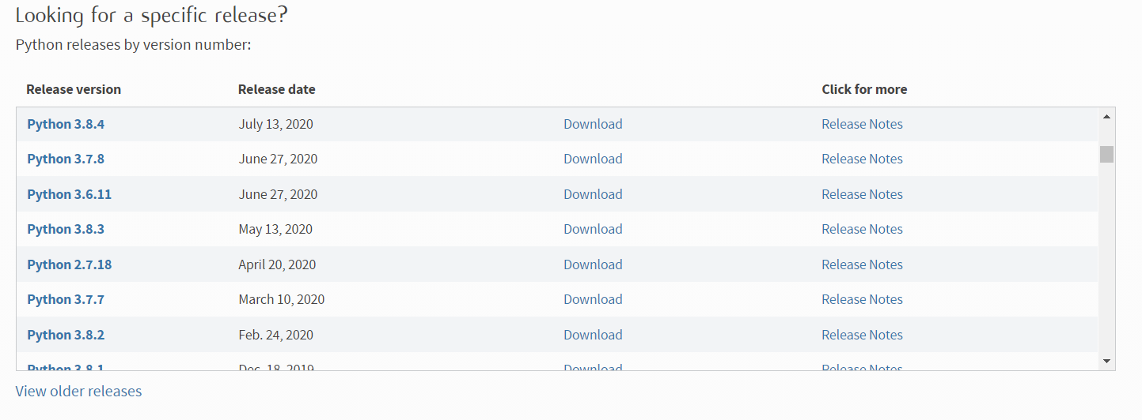

Figure ‎1.1 Python version on the website

Step 2: Select installer based on your PC OS. The installer will be downloaded.

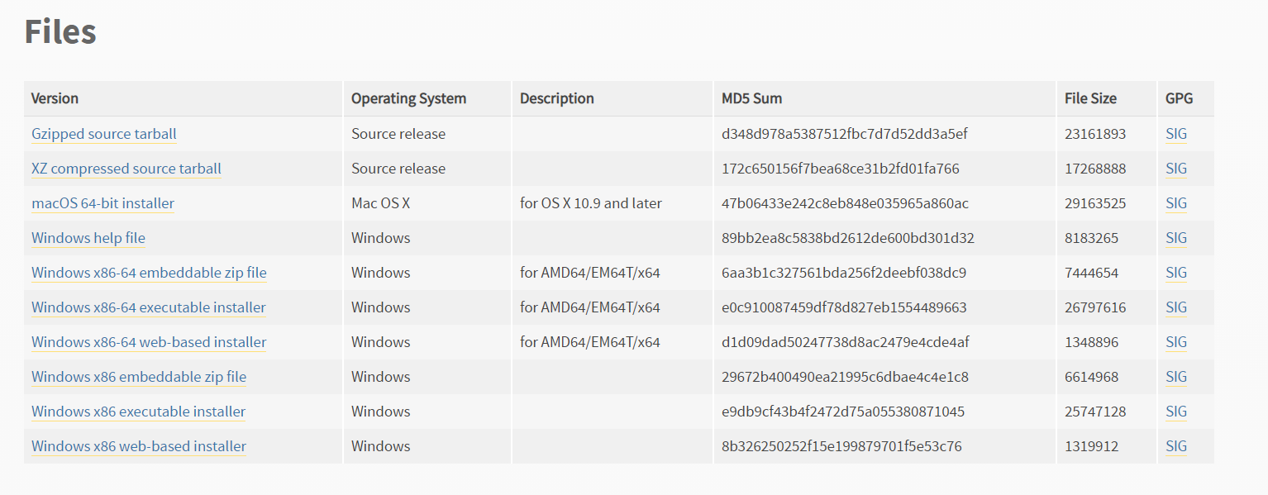

Figure ‎1.2 Installer based on OS

Step 3: Double click the installer.



Figure ‎1.3 Python 3.7.7 Windows Installer

Step 4: Checkmark "Add Python 3.7 to PATH" and select Install Now.

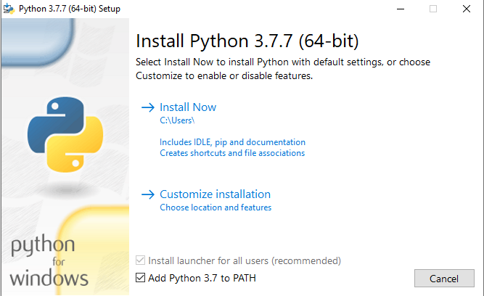

Figure ‎1.4 Python Installation Wizard

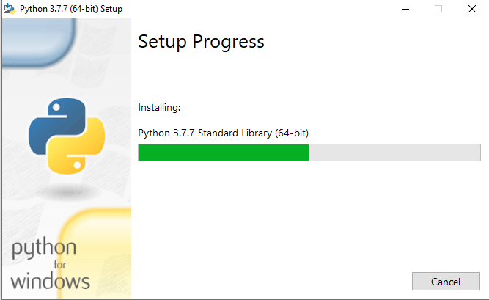

Figure ‎1.5 Python Installation Progress

Step 5. Python setup was successful. Click the Close button.

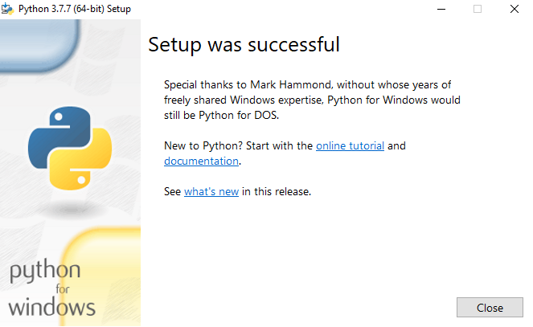

Figure ‎1.6 Python Installation Successful

# Tensorflow Installation

Step 1: Open command prompt

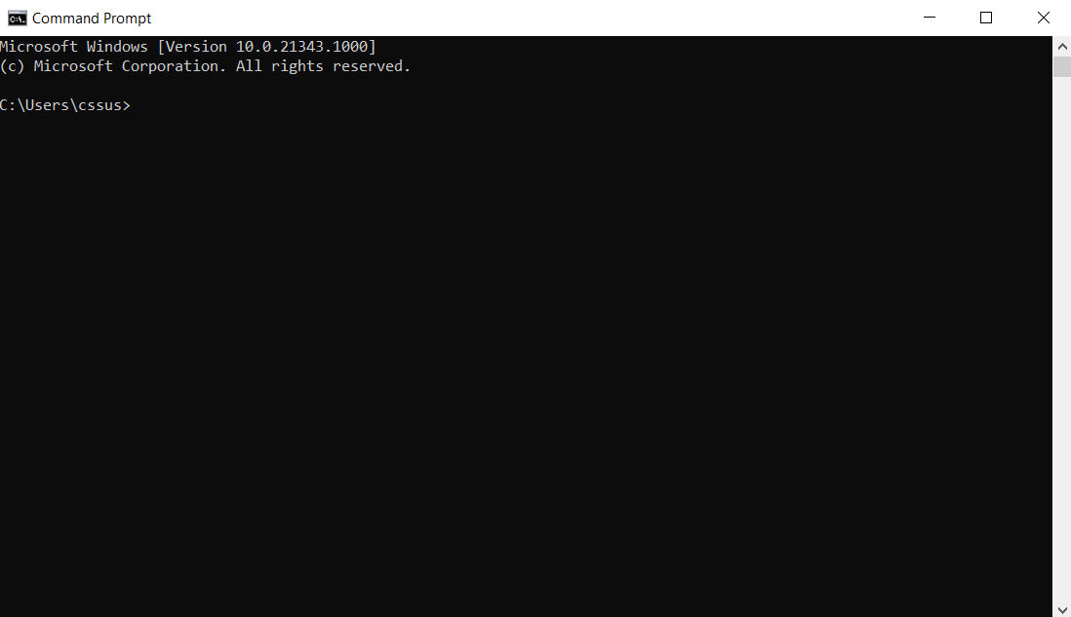

Figure ‎2.1 Command Prompt Interface

Step 2: Type command as below:

1. pip install tensorflow==1.15
2. pip install tensorflow-object-detection-api
3. pip install opencv-python
4. pip install flask

|  |
| --- |
|  |
|  |
|  |



Figure ‎2.2 Commands for Tensorflow

TensorFlow has been installed.

# XAMPP Installation

This XAMPP tutorial will guide you through the software package's installation on Windows. If you are using Linux or Mac OS X, the installation steps mentioned below might be different.

**\*Note:** For Windows OS, the installer is already in the TOPBuilder Web file.

Step 1: Download XAMPP Software at <https://www.apachefriends.org/download.html>

|  |  |  |
| --- | --- | --- |
|  |  |  |
| Figure ‎3.1 XAMPP Installer for different OS | | |

Step 2: Run the xampp.exe file.



Figure ‎3.2 XAMPP Installer for Windows OS

Step 3: Deactivate any antivirus software. Click Yes to continue installing XAMPP.

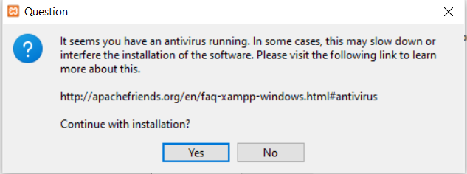

Figure ‎3.3 Deactivate Antivirus Notification

Step 4: Deactivate UAC. Click OK.

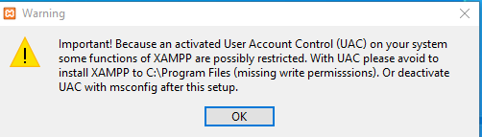

Figure ‎3.4 Deactivate UAC Warning

Step 5: Start the setup wizard. Click Next.

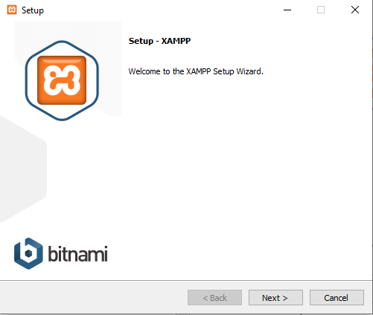

Figure ‎3.5 XAMPP Setup Wizard

Step 6: Choose components of the software. Select all and click Next.

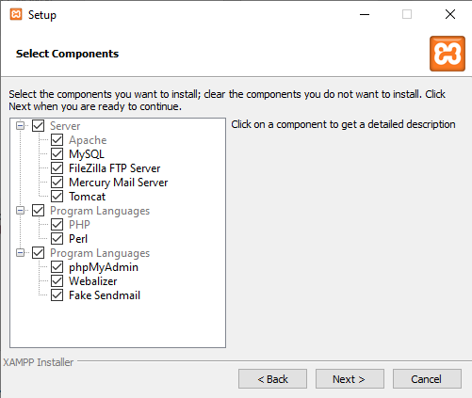

Figure ‎3.6 XAMPP Components Wizard

Step 7: Select the installation folder. By default, it already redirects to C:\xampp. Click Next.

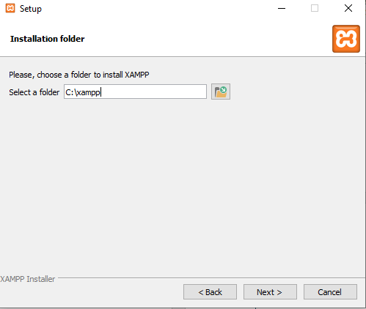

Figure ‎3.7 XAMPP Installation Folder

Step 8. Select language and click Next.

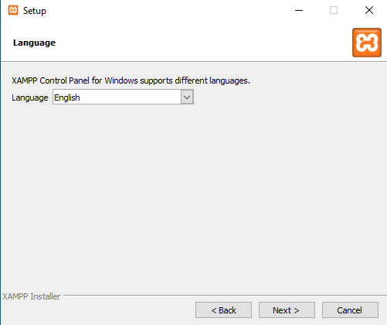

Figure ‎3.8 XAMPP Language Selection

Step 9. Bitnami for XAMPP. Click Next.

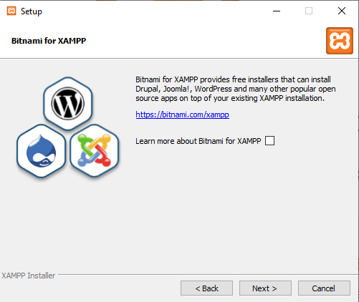

Figure ‎3.9 Bitnami for XAMPP

Step 10. Setup is ready to begin installing XAMPP. Click Next.

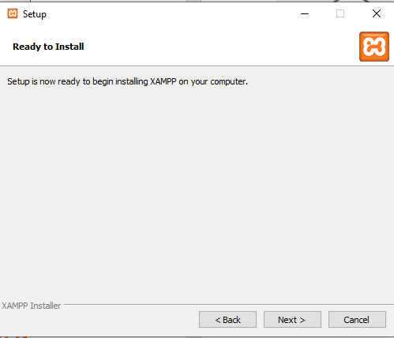

Figure ‎3.10 XAMPP Installation ready

Step 11. XAMPP has been installed. Uncheck the box if you do not want to start the XAMPP Control Panel and click finish.

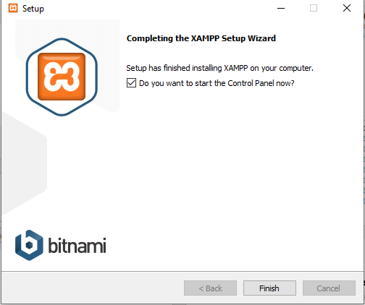

Figure ‎3.11 XAMPP Installation completed

Step 12. Copy TOPBuilder2021.zip to this directory folder C:\xampp\htdocs and extract the file.

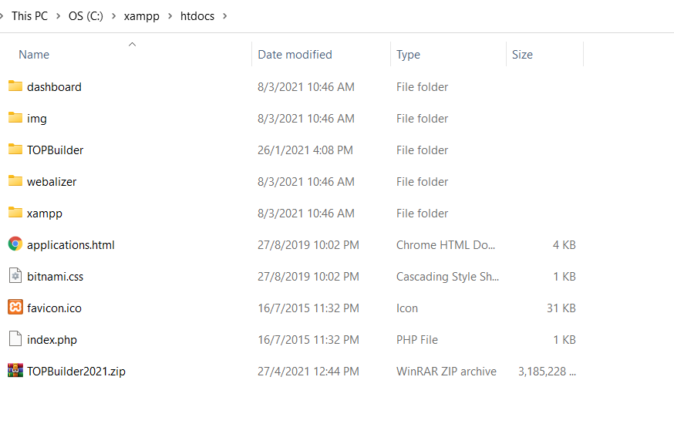

Figure ‎3.12 TOPBuilder file directory

Step 13. Open XAMPP Control Panel and Click Start at Apache section,

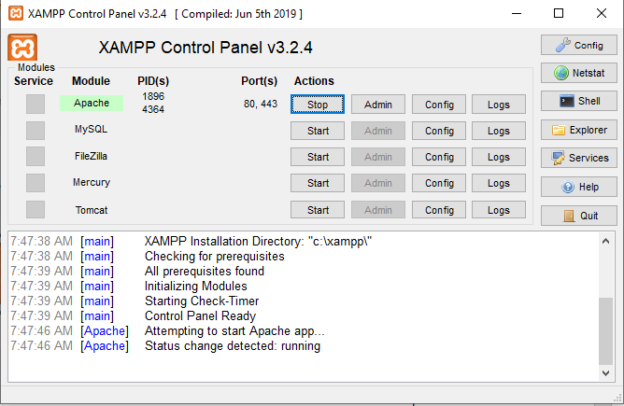

Figure ‎3.13 XAMPP Control Panel Interface

# Start Tensorflow Model

Step 1. Open folder C:\xampp\htdocs\TOPBuilder\models\research\object_detection and Click start.bat

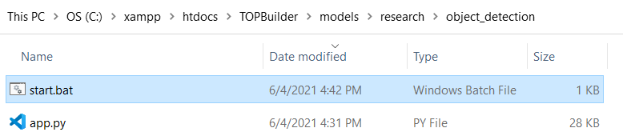

Figure ‎4.1 Start.bat for detection model directory

TOPBuilder website function for detect PPE and incidents is running. Users can start using the TOPBuilder web application.

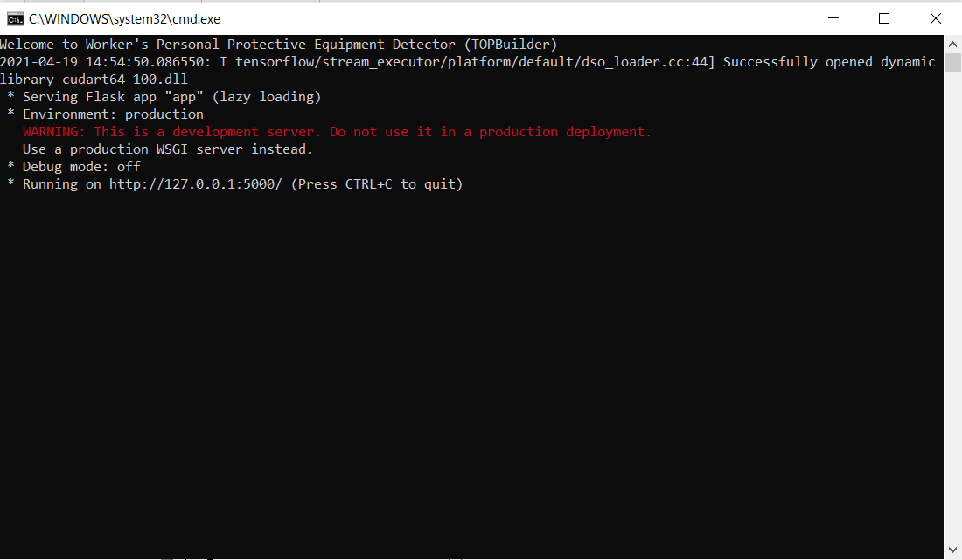

Step 2. Hold Ctrl and C to terminate the running program. Type Y to terminate the process.

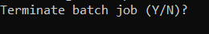

# TOPBuilder Website

Step 1. Open any web browser such as Google Chrome and type localhost/TOPBuilder. 

Figure ‎5.1 TOPBuilder Main Page

Step 2. Select About tab to view the descriptions of the detector.



Figure ‎5.2 TOPBuilder About Interface

Step 3. On the Detection tab, select your desire detectors, such as image detector, video detector, webcam detector for PPE, and incidents.



Figure ‎5.3 TOPBuilder Detection Tab

Step 4. On the Contact tab, users can get info, location and send messages to NIOSH.



Figure ‎5.4 Contact Us Interface

## PPE image detection

Select Choose File button to choose an image to detect and click the submit button.

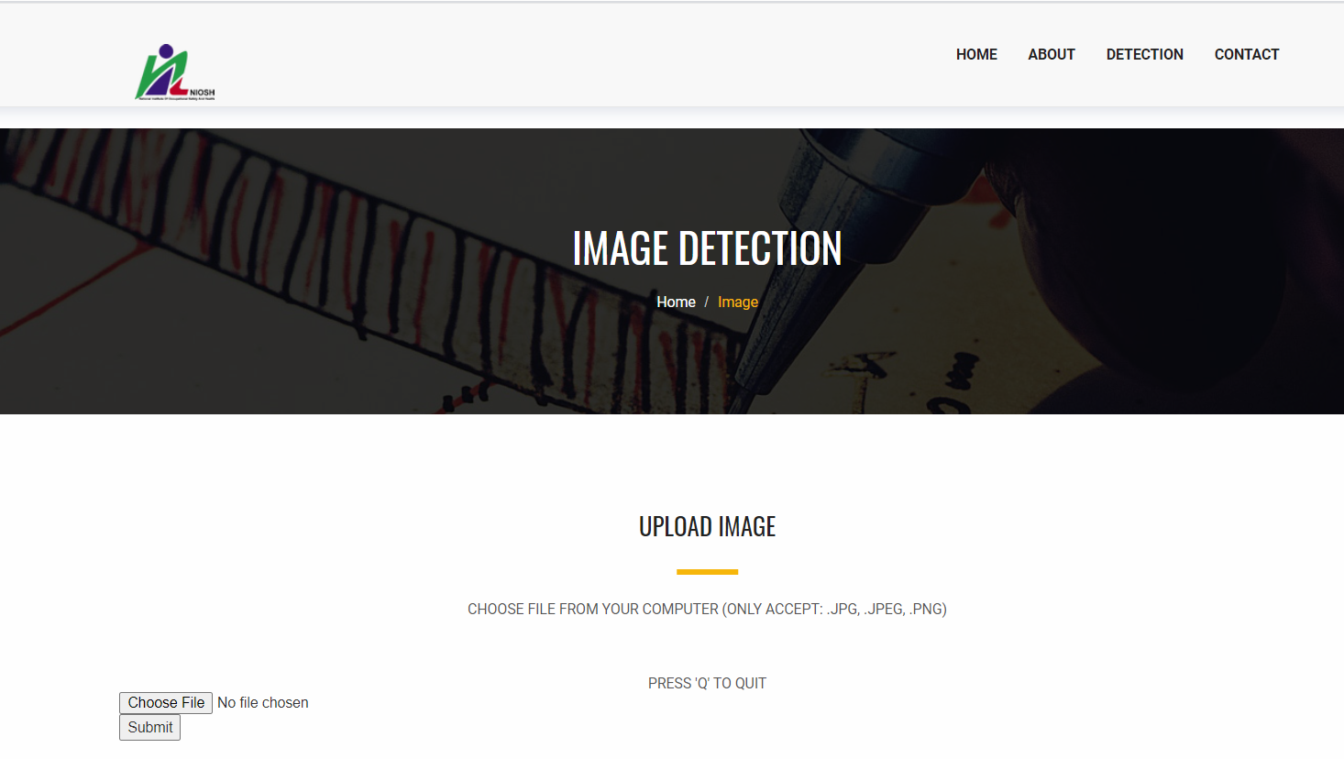

Figure ‎5.5 PPE Image Detection Interface

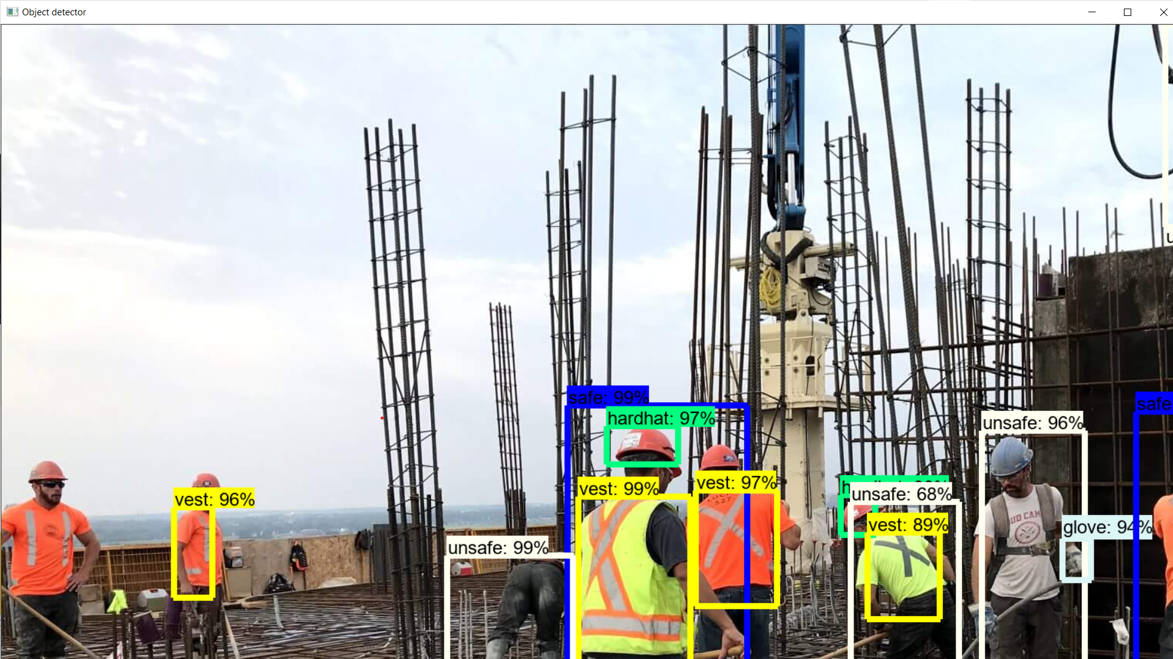

Figure ‎5.6 Sample for PPE Image detection.

## PPE Video Detection

Select Choose File button, choose the video to detect and click the submit button.

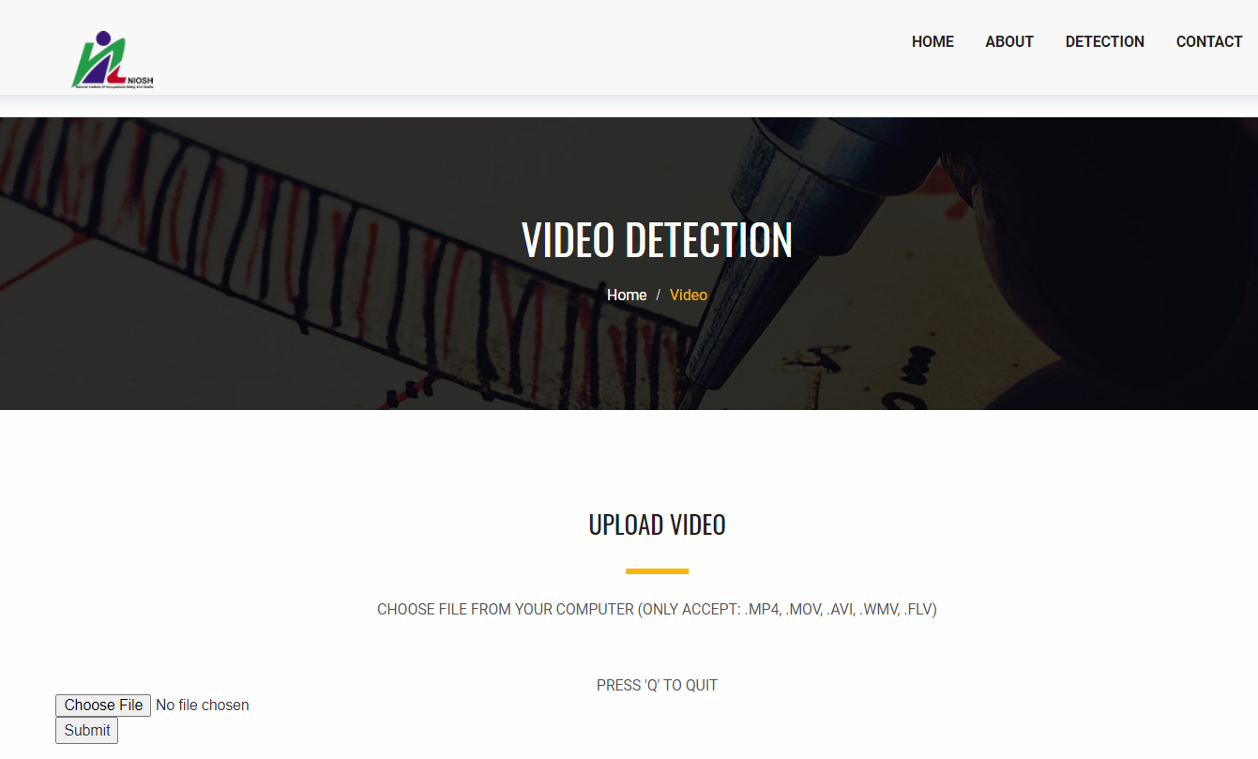

Figure ‎5.7 PPE Video Detection Interface

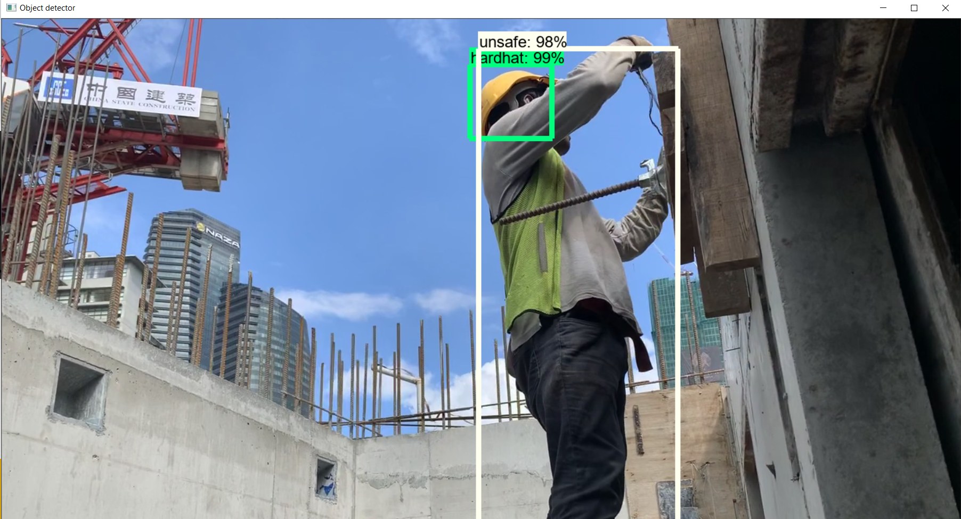

Figure ‎5.8 Sample for PPE Video detection

## PPE Webcam Detection

Select OPEN CAMERA button to open the webcam. Press Q to quit the camera.



Figure ‎5.9 PPE Webcam Detection Interface

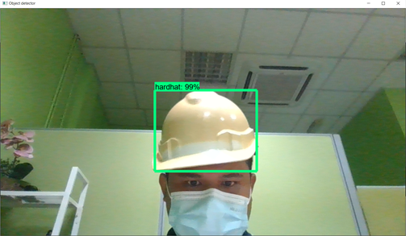

Figure ‎5.10 Sample for PPE Webcam detection

## Incident Image Detection

Select Choose File button to choose the image to detect and click the submit button.

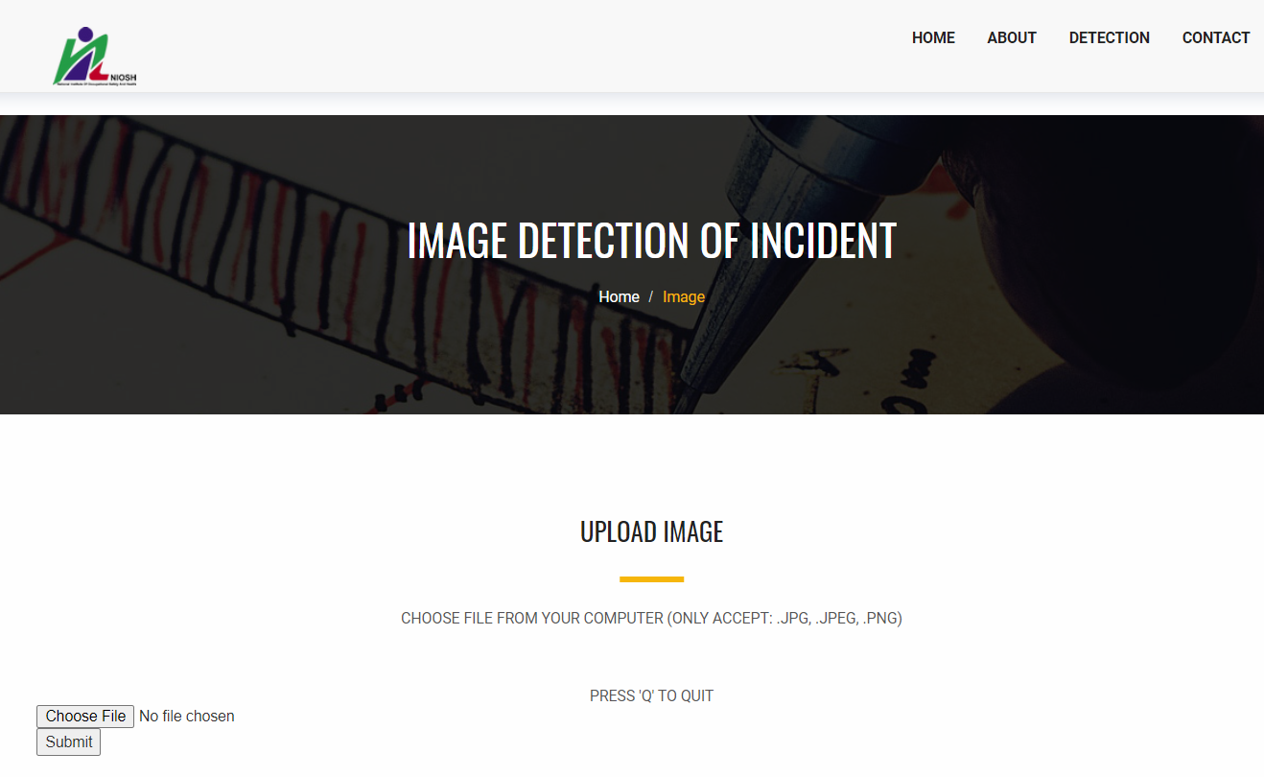

Figure ‎5.11 Incident Image Detection Interface

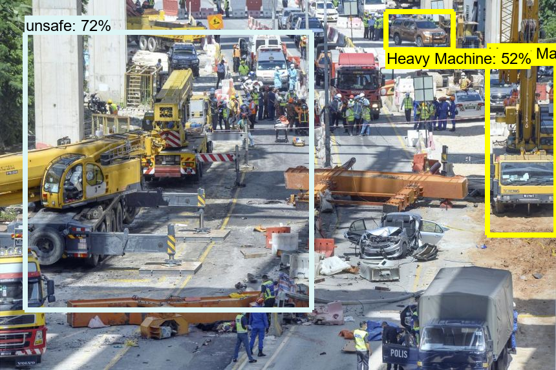

Figure ‎5.12 Sample for Incident Image detection

## Incident Video Detection

Select Choose File button, choose the video to detect and click the submit button.

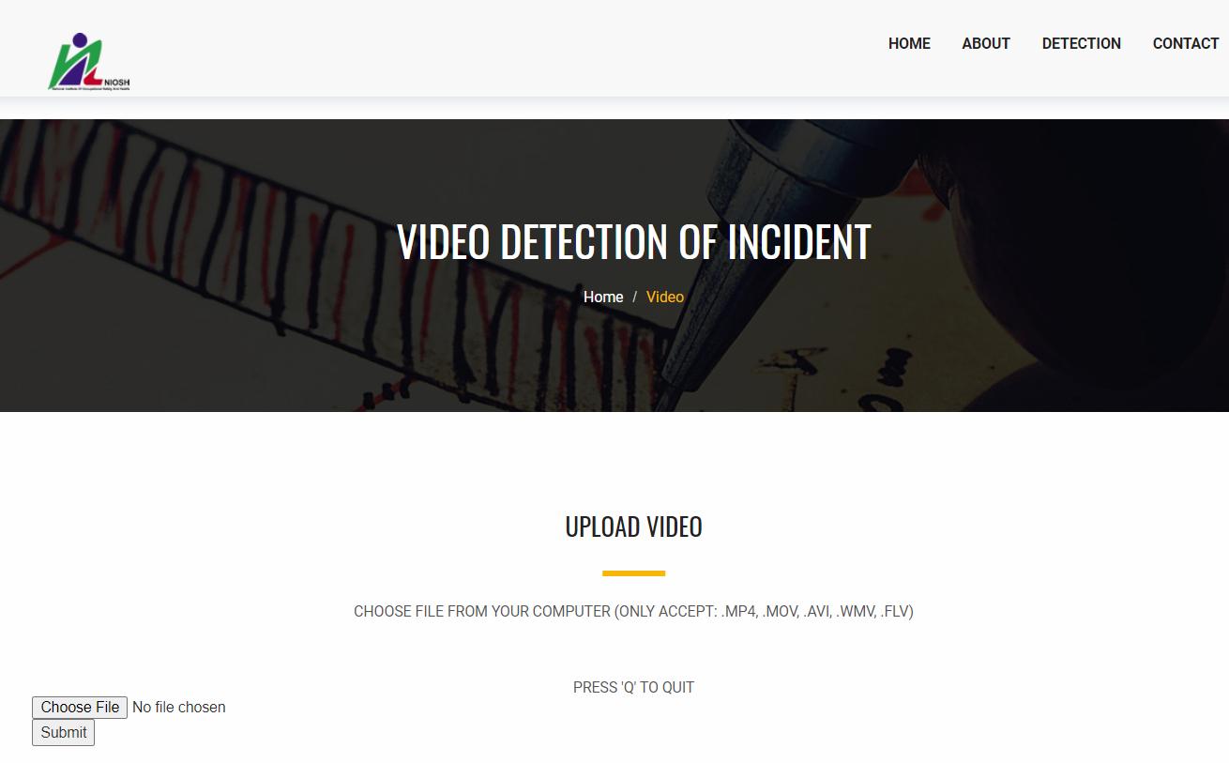

Figure ‎5.13 Incident Video Detection Interface

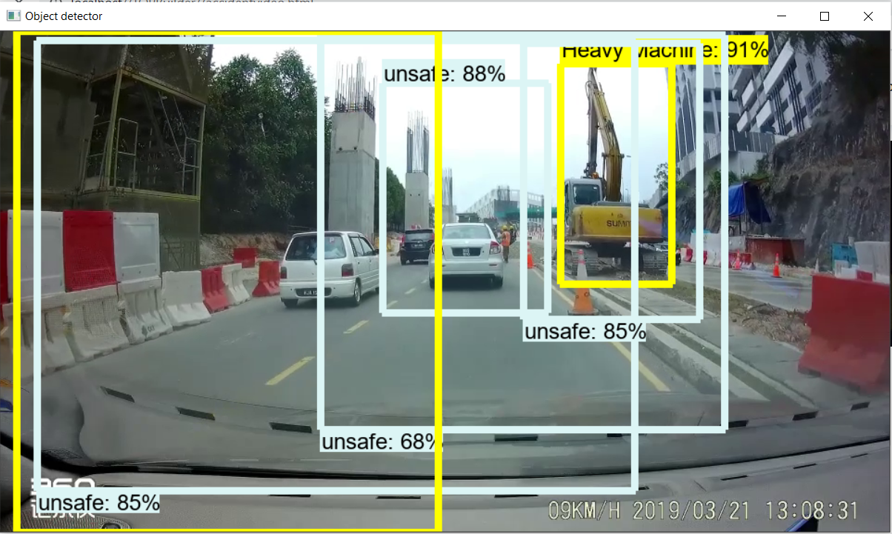

Figure ‎5.14 Sample for Incident Video detection

## Incident Webcam Detection

Select OPEN CAMERA button open webcam. Press Q to quit the camera.



Figure ‎5.15 Incident Webcam Detection Interface

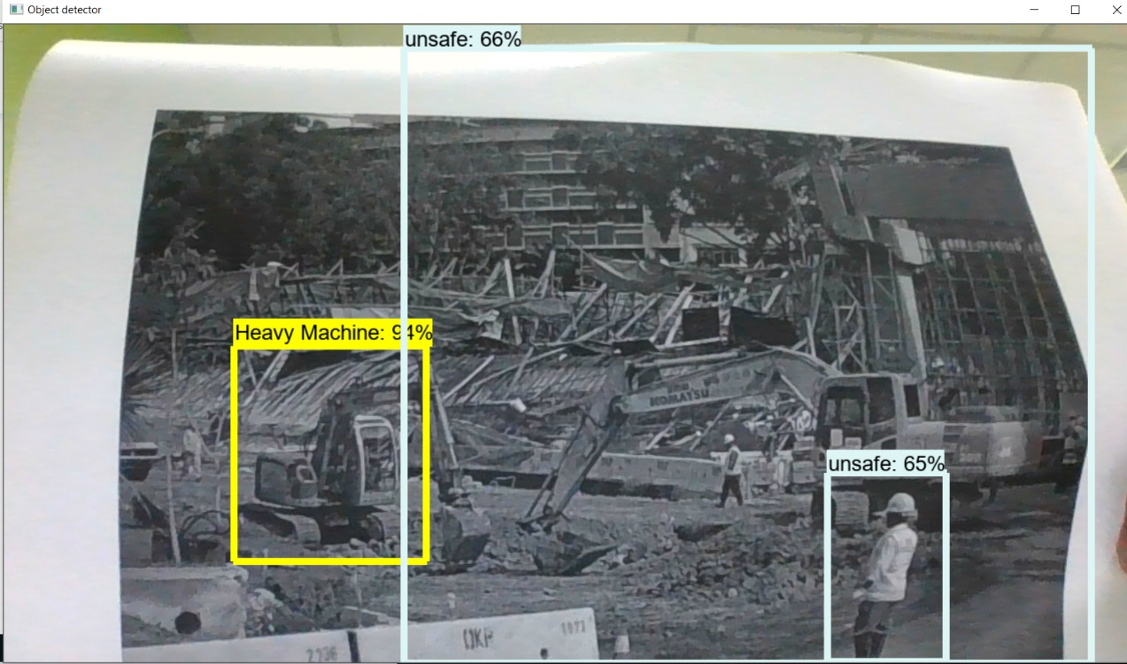

Figure ‎5.16 Sample for Incident Webcam detection